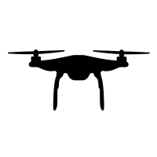

Eliminate background high frequency noise by LPF

Calculate the probability of presence of speech in the noisy input using VAD

Estimate the weights for the noise components using the speed data and speed-noise relation and applying GCS optimization

Multi-channel Wiener Filtering to suppress the estimated noise

Obtain the M-channel STFT to estimate the Cross-Correlation in frequency domain

Identify the peak in the phase plot

Estimate the Azimuth and Elevation angle using GCC-PHAT algorithm

Clean Speech

Wind noise and ego noise generated by rotating motors and propellers

M-channel audio inputcontaminated by ego motor and wind noise

Motor noise signal at sample speeds

Speed data of the motors during the particular recording